# MANUAL TESTING

# Software

## Collection of computer programs that help us to perform a task.

## E.g.: If we want to use our mobile, we need some software to be installed in it(like apps etc..).

# Programs

## Instructions to computer(coding) that is understandable by computer.

# Types of Software:

# System Software

## If we are connecting keyboards, printer etc. to our computer for that we need to have some driver(software) installed into our system.

## We need their help to run the system because how our computers can identify the keyboard when its connected. There should be some software to identify the mouse, keyboard, keyboard.

## If you don’t have any operating system in our computer, then how we install other software’s to our system.

## Once you have computer you have to install OS that is the base.

## On top of OS, we will install other software’s.

## These software’s are used to run the system.

# Example: Device Drivers, OS, Servers, Utilities

# Programming Software

## Developers are writing some programs(coding) then how the program will be executed and how it will produce output. When we give some input to the computer someone should be there to process the input internally and produce the output.

## We cannot see system and programming software

# Example: Compilers, Debuggers, Interpreters etc.

# Application Software

## Users will use that software.

## Everyday we are using web application like Facebook, twitter etc. or online portals.

## All apps in our mobile(with Internet from playstore).

## Word, excel, calculator etc(Without internet also we can use desktop application).

## We can perform some tasking using this application software like financial, education application.

# Software Testing

## It is a part of Software Development Process.

## Suppose we want to buy a mobile, we have some budget, and we are expecting some feature to fall under that budget. Now we bought the mobile and started using the mobile. You found some issues in mobile some things not working. Why this happened because lacking in testing(Testing not conducted properly).

## Same things will happen in software also.

## X bank(company)-> explain their requirements(the actions(Manual Transactions) they perform in their bank and now they want to automate it(with some budget))-> IT Company(Agree to develop the software and test the software and deliver the software to the X Bank Company based on their budget).

## It is an activity to detect and identify the defects in the software.

## **To deliver quality product** to customer we need software testing.

## Tester must make sure that the application or software is working as expected(given requirement) by the customer.

# Software Quality

## Customer justification

## How well our product or software is working? This will be decided by customer.

# Certain Parameter decide product is in good quality:

# Bug-Free

## Our Product should not have any bugs.

# Delivered on Time

## If development and testing, take more than committed time again customer must spend budget to employers and staffs. So, product must be delivered on time

# Within Budget

## Initially the organization will have some budget and once you start developing and testing if budget increases that will not fall under quality product.

## Whatever budget and time we committed we must deliver in that manner. Nothing could be changed.

# Meets requirement and Expectations.

## The software should work as expected by the customer.

# Maintainable

## It should be user friendly.

## Whenever there are any small issues, they should be able to resolve themselves.

# To deliver quality product we perform testing but when we say product is quality then it should accommodate all the above parameters.

# Project

## If software application is developed for specific customer based on the requirement, then it is called Project.

## Suppose I develop a software for an organization only that organization can use that software others cannot use it.

## **Service-Based Companies**(Infosys, Accy, TCS) deal with Project. They will work for specific client.

# Product

## If software application is developed for multiple customers based on the market requirements, then it is called Product.

## **WhatsApp** : Everybody using. They developed based on the customer requirement. They analyze the requirement from the market(people) then they consolidate all the requirement and develop the software.

## **Product-Based Companies**(Google(Gmail, Maps, Driver), Microsoft(word, office) deal with Product.

# Error

## Human mistake. While performing some tasks if human did some mistake, then it is called error.

## Incorrect Human Action.

## If developer writing some code and he by mistake, he typed something else and that is causing the error.

# Bug

## Deviation from expected behaviors and actual behaviors in application.

## Also called Defect.

## Even if I give invalid credentials it is logging into the application then it is a bug.

# Failure

## Deviation identified by End User while working with the software.

## After we deliver the product to the customer, and then they are facing some issues it is not working properly then it falls under Failure.

# Why the Software has bugs?

# Mainly 5 reasons

# Miscommunication or No Communication

## There is no proper communication between developers and tester.

## If requirement is having some functionality and developer has developed some other functionality and tester is expecting something.

# Software Complexity

## Suppose the software is so complex, if it has n number of modules, more people are working in that case we can miss something.

# Programming Errors

## Developer written some program(adding two number(2+3)). Programming is executing fine, but the output is not as expected. Instead of 5 it gives 10 which is incorrect.

# Changing Requirements

## In middle of development again customer come back and change the requirement which initially they didn’t say. Sometimes it may possible and may not be possible to change the application according to their requirement.

## Even if the customer requirement is frequently changing that is also reason of bugs.

# Lack of Skilled Testers

## If tester doesn’t have proper skill set, he will miss the bugs. Then it will come into production.

## Tester focus is to break our application with our skillset.

# SDLC(Software Development Life Cycle)

## It is a step-by-step process used by software industries to design, develop and test the product.

## Entire process to deliver quality product.

# Whatever company we say they will go through some phases:

## Take some requirement from the customer.

## Do some design for software based on the requirement.

## Implement the code or develop the code or software.

## Conduct testing on the software

## Release the software to the customer.

# Three Pillars of Company

# People

## Company needs people to do design, development, testing.

## Without people there is no company

# Process

## If we want to perform something, then we need to follow some process which we must follow based on the company.

# Product

## If we want to deliver the product to the customer, then people should follow certain process.

# SDLC High Level Overview

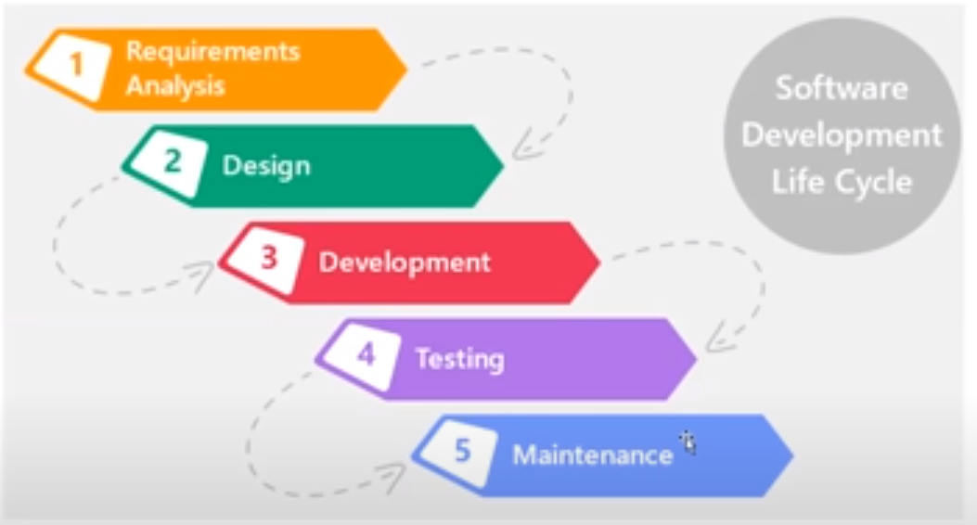

## Collect and Understand requirements from the customer.

## Design the software. How the UI should look and all navigations. Divide the requirement into High Level and Low-level modules. Finally, it will be integrated.

## Based on the design document Developers will write code(develop software).

## After Development or implementation is completed, we must perform different types of testing before delivering the software.

## Finally, we deliver the software.

## We deploy(install) the software in customer environment, and they start using.

# Types of Process Model

# Waterfall Model or Linear Model

## Documentation plays very important role.

## Every activity will be documented.

## Business Analyst or Product Manager involve in communication between customer and organization.

## They will collect the requirement from the customer, and they prepare a document called **SRS**(Software Requirement Specification Document)

# SRS:

## Contains every requirement from the customer.

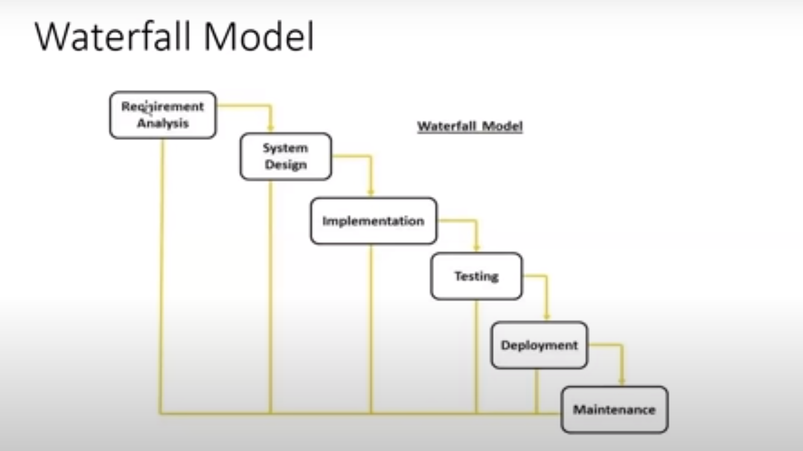

# Requirement Analysis

## Input from customer and output is SRS.

# System Design

## SRS is input and design document is output.

# Implementation

## Design document is input, and code(software) is the output.

# Testing

## Software is the input which is provided by the developer and output is Test Case, Test Results, Test Plan.

# Deployment

## Prepare installation , User manual document and function flow how the software works. Based on that customer will start using the software.

## Each phase is dependent on the previous phase input.

## Until unless requirement Analysis phase is completed, I cannot start the design.

# Advantages:

## Quality of product will be good because every phase has detailed documentation.

## Frequent Requirement changes are not allowed so chances of finding bugs will be less.

## Initial investment is less since the testers are hired at later stages. Initial stage we need only BA, PM until unless we completed first 3 stages, we don’t need testers.

## This model is used for small and long-term project. Also, where requirements are freeze.

# Disadvantages

## Requirement changes are not allowed. We cannot accommodate frequent changes requirement in the software.

## If there is any mistake in the requirement that same mistake will be continued in the next stages.

## In testing phase, we found a defect we must go back to previous stage and change those. It will cause rework and investment must be done for that.

## Testing will start only after coding(one phase of testing).

# Spiral Model or Version Control Model

## To overcome drawbacks of waterfall, model this model comes into picture.

## When one cycle(10 features) is completed, we deliver one version of software to the customer.

## Again, on top of this existing software, customer will give the requirement. Again, second cycle(5 new features or new changes in the previous requirement) is completed, version two of the software is delivered.

## In every cycle new software will be release to customer. Software will be release in multiple versions. So, it is also called version control model.

## In every cycle we follow SDLC process(same kind of process)

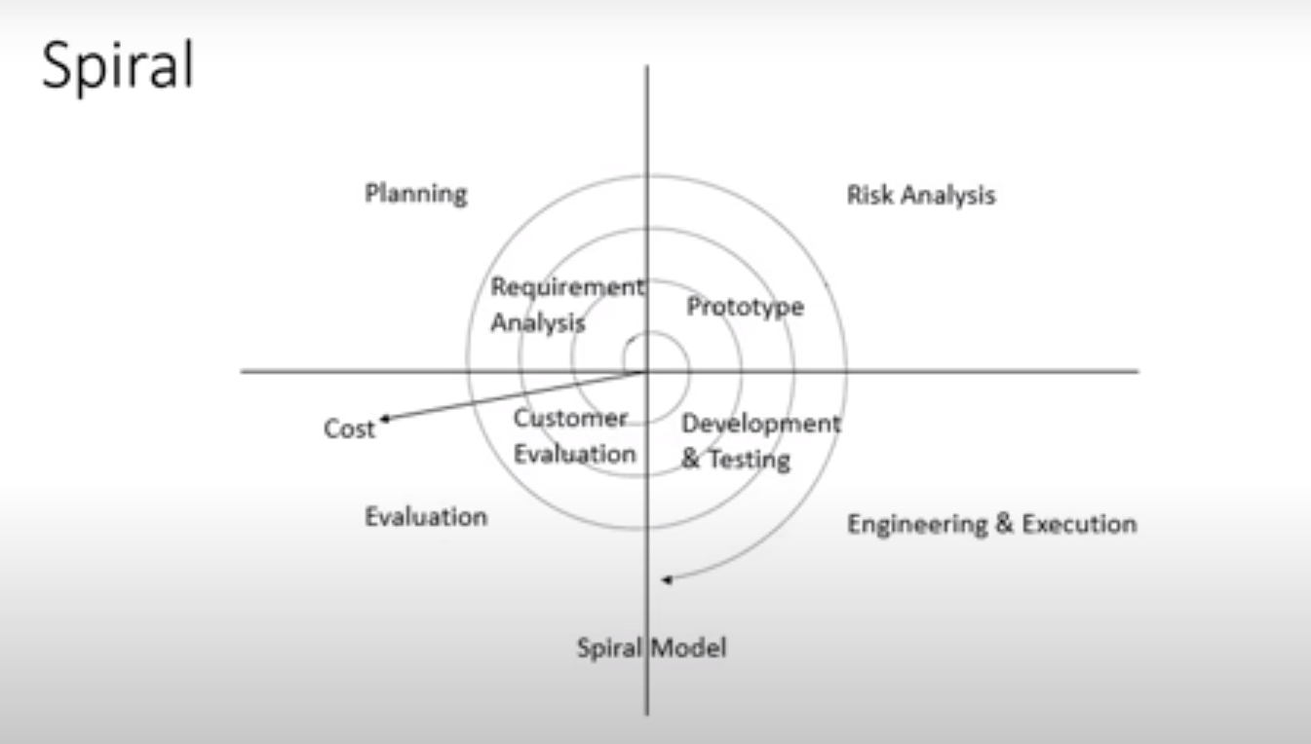

## It is mostly preferred by Product based companies.

## Every time the market requirement will be changed and accordingly, we must implement new feature in the software.

## Eg. **WhatsApp** : Initially WhatsApp has a smaller number of features after that every time we are getting upgrades(new features) so based on customer requirement they implement new features on top of existing software, and they release the software to customer.

## We follow spiral model whenever there is a dependency on modules.

# Advantages

## Testing is done in every cycle before going to next cycle.

## Requirement changes are allowed after every cycle before going to next cycle but not in the middle of the cycle.

## Customer will get to use the software for every module. No need to wait for the completion of complete software.

# Disadvantages

## Requirement changes are not allowed in between the cycle.

## There is no testing in requirement and design phase.

# Prototype model

## Blueprint(sample) of the software.

## Get Initial requirements from the customer.

## We don’t develop the complete software we will develop the prototype(ie sample of the software)

## We show(demo) it to the customer if the customer satisfied with this prototype, then we start with design coding testing and different phases.

# Module

## All application features are divided into different parts. They are called modules.

## Entire software cannot be built(develop) in one shot. So, the entire software will be divided into multiple parts and different develop will work on different modules.

# V-model or VV Model(Verification and Validation)

## Every phase of SDLC we conduct testing.

## In V model one part we do static testing and another part we do dynamic testing.

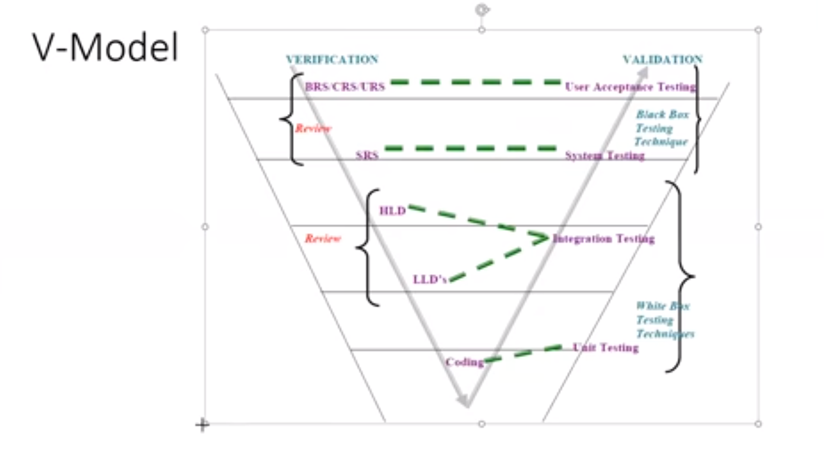

# BRS(Business Requirement Specification)/URS(User Requirement Specification)/CRS(Customer Requirement Specification)

## The requirements given by the client or customer will be noted in this document.

## Based on this requirement we conduct one testing called User Acceptance Testing.

## BRS is input for UAT. Once the BRS is ready review(Make sure content in document is correct or not, all requirements are captured or not) will be done by the Business people.

## It describes at very high level the functional specifications of the software.

## It is a formal document describing about the requirement provided by client (written, verbal)

## Usually, its created by the [Business Analyst](https://www.guru99.com/business-analyst-tutorial-course.html) who interacts with clients.

## It is derived from client interaction and requirements.

# Who prepare that document?

## In our company we have a team called Business Unit those people will interact with the customer, and they collect the requirement, and they will prepare the document.

## This document more can be understand by the Business people. Technical people cannot understand this.

## It is very huge document.

# SRS(Software Requirement Specifications)

## Based on BRS another document is prepared which is called SRS which contains technical details(format).

## SRS is prepared by Product Manager or Project Manager.

## Especially developers and testers can understand.

## It specifies the functional and non-functional requirements of the software to be developed.

## It describes at a high level , the functional and technical specification of the software

## Usually, its created by the System Architect who is an technical expert .

## Based on SRS document the designers will prepare HLD(High Level Design Document) and LLD(Low Level Design Document).

## It is derived from the BRS.

## Entire application is divided into main module(HLD).

## Each module is divided into sub modules(LLD).

# Testing Techniques used to verify the documents:

## Review

## Walkthrough

## Inspection

# Static Testing

## Testing the project related documents not the software in the form of review, walkthrough, inspections.

# Unit Testing

## Whatever module is developed by the developer if you test that module then it is called Unit Testing.

## Testing Single component(module) of the software.

## After completion of coding first unit testing will be conducted by developer.

# Integration Testing

## After completion of all the modules, they will be integrated and make them as one main module. Then we test that main module.

## Developers perform testing once all the modules are integrated that is called Integration Testing.

## To conduct **unit** and **integration** testing we must know the coding part. So, Developers will conduct these testing.

## Hence Unit Testing and Integration Testing comes under **White** **Box** Testing because it must be done in code level.

# White Box Testing

## Whatever testing we conduct on the code or submodules or main modules which is called white box testing technique.

## We must know internal logic of the programs.

## If you want to test the single module, we must know what type of code the developers are written.

# System Testing

## After completion of Unit and Integration Testing, System Testing will be conducted.

## Basically, they don’t need to understand the code they just verify or test our software is working according to customer requirement or not.

## Functionality is working or not. We don’t need to have programming skills in system testing.

## Tester will do this testing.

## System testing comes under Black Box Testing Technique.

# User Acceptance Testing

## After completion of System Testing, User and Customer will do some kind of testing at their level.

## This is also done by testers along with customers.

## Here also we don’t need to understand the code which also comes under Black Box Testing.

# Dynamic Testing

## Testing the actual software by using Unit, Integration, System and UAT testing techniques not the documents.

# Verification

## Before software is ready, we conduct Verification.

## Focus on documentation.

## Checking each and every document (ie the software artifacts) is correctly written or completely written so that it helps to check whether we are building the right product.

## Checking every document(artifacts) to verify whether we are building the right product.

## Focus on Documentation.

## It involves Reviews, Walkthroughs, Inspection.

## It includes Static Testing Technique.

# Validation

## Takes place after verification is completed.

## **Testing** the **actual software** whether it is working according to customer requirement or not.

## Focus on software.

## Checks whether we are building the product right.

## Testing the product. Whether it meets the user requirements.

## It involves Unit, Integration, System and UAT.

## It includes Dynamic Testing Technique.

# Advantages

## Testing is involved in all stages.

# Disadvantages

## Documentation is more.

## Initial investment is more.

# Review

## To ensure correctness and completeness on content.

# Types

# Requirement Reviews

## To understand the requirement, we review them.

## Each requirement is mentioned or not. Correct or not.

# Design Review

## Software will be designed in the form of diagram and pictures. Those design documents will be reviewed.

# Code Review

## Written code is logically correct or not.

## Sometimes another developer will review whether he followed proper standard or not .

# Test Plan and Test Case Review

## Test case will be reviewed.

## How many defects raised, how many fixed, how many open everything will be reviewed.

## Anyone in team can review.

# Walkthrough

## It is an informal review(No proper plan and schedule).

## Author(Whoever created the document) reads the document or code and discuss with peers.

## At least two should be there.

## Does not have minutes of meet.

## Its not pre-planned and can be done whenever required.

# Inspection

## More formal.

## Preplanned

## Send invite to team members on particular time(Dev, QA, Managers etc)

# Three types of people involved in inspection:

# Reader

## Author(whoever created the document).

## He will read the document.

# Writer

## Team raises some question or clarification.

## He notes down all the clarification and issues.

## Writes Minutes of Meeting and share with the team.

# Moderator

## Mediator between author and rest of the team.

## He is an organizer.

## Sometimes moderator also note down MOM.

# QA(Quality Assurance)

## Process related/oriented.

## Focuses on building in quality.

## Preventing the Defects. If we follow process correctly, we can prevent the defects in future.

## If there is a company there will be 3 pillars(people, process, product).

## People belongs to the QA will always defines the process.

## Ensure rest of the people are following the process properly.

## High Level Management people will come under QA.

## QA involves in every stage of SDLC(entire life cycle) because they are taking care of process.

# QC(Quality Control)

## QC is talking about the people (ie. Tester)

## Focuses on testing for quality.

## Detecting the Defect.

## Product Oriented.

## Actual testing of the software

## They are involved **only during testing**(testing part in SDLC).

## People who are working under testing comes under QA.

## They test the software whether it meets customer requirement or not.

## Manual Tester

## Manual and Automation together.

# QE(Quality Engineering)

## Advanced term

## Write code to test the software.

## Team contains only Automation Tester.

## Refers only Automation Tester.

# Levels of Testing

# Unit Testing

## Entire application is divided into multiple units/modules/components.

## A unit is a single component or module of a software.

## Small piece/small module of code will be tested.

## As soon as coding is started developer will do unit testing.

## It is conducted by the developers at coding level.

## It is white box testing technique.

## Testers will perform **component** **testing** at UI/Application level.

# Example: Let’s take Gmail

## Composing email one module.

## Searching email is one module.

## Deleting email is one module.

# Unit Testing Techniques

# Basis path testing

## Developer written some program with multiple lines. Each line should be executed at least one.

# Conditional coverage

## All possible conditions like positive inputs and negative inputs developer will verify.

# Loops Coverage

## Same statement will repeat multiple times based on certain conditions.

# Mutation Testing

## Test the code by passing different types of inputs.

# Integration Testing

## Performed between two or more modules.

## Focuses on checking data communication between multiple modules.

## White box testing technique.

## Combining all the modules and checking the data or workflow.

## Developers will perform integration testing at code level.

## Testers will perform integration testing at UI/Application level.

# Types

# Incremental Integration Testing

## Incrementally adding the modules and testing the data flow between the modules.

## First check communication between two modules.

## Then keep on adding new module with existing modules to test the workflow.

## Not integrating all the modules at once. Integrating one after another and testing.

# Two Approaches

# Top-Down Incremental Integration Testing

## Ensure the module added is the child of previous(parent) module.

## Compose Email – Parent module(until unless we compose and send it will not present in sent items).

## Check Sent items - Child module.

# Bottom-Up Incremental Integration Testing

## Ensure the module added is the parent of previous(child) module.

# Sandwich/Hybrid Approach Incremental Integration Testing

## Combination of Top-Down and Bottom-Up approaches

# Non-Incremental Integration Testing

## Integrate/Add all modules at one shot and test the data flow between modules.

## If we have 10 modules in the application, then we will wait until all 10 modules is completed and then integrate them all in single shot and test the flow.

# Drawbacks

## We might miss data flow between some of the modules.

## If you find any defect, we can’t understand the root cause of the defect.

# System Testing

## Testing overall functionality/feature of the application/software with the respective client requirement.

## Black box testing technique.

## Conducted by testing team.

## Not going to touch the code, get application from develop we install it and then test the application.

## Before conducting system testing we must thoroughly understand the customer requirement, understand flow and UI of the application.

## **Third Level of Testing** : After completion of component and integration testing, we start system testing.

# System testing focuses on below aspects:

# User Interface Testing(GUI)

## Process of testing the User Interface of the application not the functionality(working process).

## It includes all the elements such as menus, checkbox, buttons, colors, fonts, sizes, icons, content, and images.

## Mainly focus on Frontend.

## Testing the UI Part

## All images properly aligned or not.

## Logo is present or not.

## Text box, checkboxes, dropdowns, colors, font, look and feel of application are displayed properly or not.

## Page Navigations.

## Color of the Link.

# Frontend

## Wherever the user is interacting with the application that is called Frontend part.

# Backend

## Actual data is stored in backend(database, server).

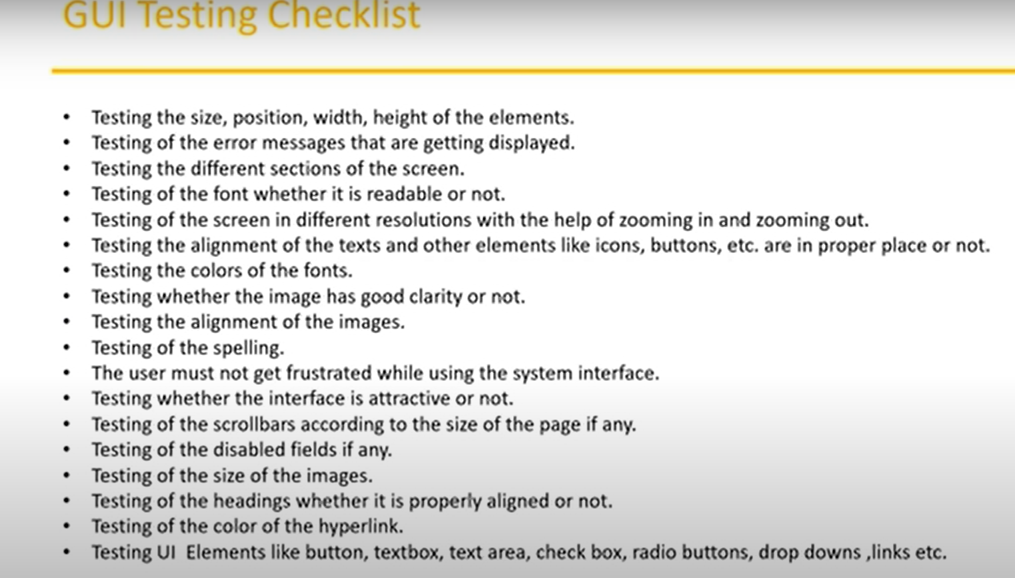

## From designers we will get the input(HLD, LLD) which the expected output to test GUI.

## We also have design document; it specifies the wireframes.

## Wireframes are dummy screens(Mock pictures).

## Before developing the application, they draw the pictures of the screen. Using that we can validate the Size, width, and height.

# Different Sections:

## Header

## Footer

## Logo

# Functional Testing

## Functionality of the application (Behavior of the application)are working properly or not.

## It talks about how the feature should work.

## Here we are not checking the UI, we are checking the functionality of the element(password field should contain at least 10 characters with special characters).

# Example(Functionality)

## Search of email.

## Delete email.

## Compose email.

# Example

## Login functionality

## Money transfer

## Adding Beneficiary

## Check Balance.

# Focus on Main aspects:

# Object Properties Testing

## Every element on the webpage is having certain number of properties(enabled or disabled).

## Check the properties of objects present on the application.

# Example:

# Focus Attribute:

## As soon as I enter the input the cursor automatically moves to the next field and wait to enter text.

# Database Testing

## Backend Testing

## Actual Data will be stored in database.

## Whatever we are browsing in the UI will send to the database and we will get the data from database. But as user we cannot see it.

## Focus on DML(Data Manipulation Language) operations. DML (insert, delete, update, get(Retrieve), Select data of employee by sending ID etc. )operations are properly working or not at database level or not.

## To check Communication between UI(Black box testing) and Database(White box testing).

## Combination of black box and white box testing. This is called **grey box testing**.

## From UI we are doing some transaction – **Black Box**

## From Database while writing queries or statement we are checking the data in table -**White Box**

## Table and column level Validation also tested(column type, column length, no of columns in the table)

## Relations between tables.

## Functions, Procedures, Triggers, Indexes, Views.

# Error Handling Testing

## Verifying error messages on UI.

## The error message should be readable(user understandable) and understandable that also we must check.

## When we do some incorrection action on UI then our application should display some error message to users on UI.

# Calculations and Manipulation Testing

## If Application is based on banking then it has some financial and banking calculations. We check whether those functionalities are working fine.

## Test the calculations with valid and invalid data.

# Link Existence and Links Execution

## Links are properly navigating to expected page or not.

## Where exactly links are placed.

# Types of Links

# Internal Links

## When we click on this link it will navigate to same page, but it will jump to different section.

# External Links

## When we click on this link it will navigate to different page.

# Broken Links

## I will not navigate to any page. It doesn’t have any target page. For Future purpose developer will place broken link in web page sometimes.

# Cookies

## Temporary data/files which are created by the browser while you browse the pages through internet.

## Cookies are related to browser.

# Sessions

## It will be created on server side.

## Once u provide username and password then it will login successfully and few minutes if u didn’t do any action on that page, then session will be expired.

## Time slot will be created/started on server side. Once u stop working on application it will count how many seconds it is inactive it will wait and then automatically close the session once time slot is over.

## This is called session mechanism. It will be mostly placed in security, banking services.

# Non-Functional Testing

## After functionalities are stable in non-functional testing will be conducted.

## Not focus on customer requirement it focuses on customer expectations.

## Special skills should be required. They have dedicated servers, machine to do that.

# Customer requirement

## Feature to be there in application.

## Fund transfer

## Check Balance

# Customer Expectation

## Install in multiple environments.

## Safe from Hacker

## Access pages quickly

## When I try to use the application performance is low, I am not getting pages quickly, application is not secure another people able to access my data. It should not happen like this. This is the expectations.

# Performance Testing

## Testing the Speed of the application.

## Mostly done only for Web Application.

# Low Testing

## Gradually increase the load on the application and verify the response time(Speed).

## Check the speed of the application.

## Slowly increase the number of users till certain number of users.

## How well and how much speed it is responding based on the user count.

## Where exactly it is breaking down, we must test that.

# Stress Testing

## Suddenly increase or decrease the load on the application and check the speed of the application.

## Somewhere it is broken or not we have to verify.

## If one server or two server is not enough, we increase multiple no of server and in every server, we place the application.

## If on slows down another server will take the request and process the request. Alternative setup in company.

# Volume Testing

## How much data the application can handle. All different data from the multiple users can fit in the database or not.

## Sometimes it will throw error and go down if data is high.

# Security Testing

## To verify how secure our application.

## Mainly focusing on Authentication and Authorization/Access Control

# Authentication

## Users are valid user or not. If valid application will allow them to access the application.

# Authorization/Access Control

## To verify the permission of the valid user.

## If user is valid, he can do certain things on the application but not everything. He will not be able to access everything on the application only something he can access.

## If that user belongs to account department, then he can only be able to access the features from account department.

# Recovery Testing

## Check the system change to abnormal(network disconnection, system shutdown) to normal(data should be there).

## By mistake If we lose some data, then I should again get back.

## To verify whether the application has ability to recover the data or not.

## Whatever mail we composed if system got shut down then that Composed email will be saved in the draft section that is recovery.

# Compatibility Testing

## Old software will be able to upgrade with the new software.

# Forward Compatibility

## Whatever new software are releasing they should be able to upgrade the existing software.

# Backward Compatibility

## The software which are already there they also compatible with newer versions.

# Hardware Compatibility

## Also called as Configuration Testing.

## Our application is able to install on multiple hardware environment/platforms.

## It is working with 4 GBRAM or 8GB RAM or not.

# Installation Testing

## Testing installation process

## Each screen is displaying correct or not when giving next.

## Screens are very easy/clear to untestable or not.

## Installation should not be complex.

## During un-installation all files related to software are deleted and removed.

# Sanitation and Garbage Testing

## To verify application is providing some extra functionality or not.

## If any application provides extra features/functionality, then we consider them as bug.

## Remove unwanted stuff(Extra functionality )from our application .

# Usability Testing

## During this testing we validate whether application is providing context sensitive help to user or not.

## Kind of help we providing to the application. Whether our software or product is providing help to the customer or not.

## As a user, they should feel comfortable with the application everything seems should be easy. That we should verify using usability testing.

## Easiness of application.

## Checks how easily the end users can understand and operate the application.

## If user struck somewhere and user is not able to do something he can refer help menu, then he can do the action.

## Verifying the user manual.

# User manual

## How to use the software.

# Software Testing Terminology

# Regression Testing

## Whenever developer changes something in the build because of that there should not be impact on another module that we have to test.

## Suppose we have 4 modules and found a bug in one module in build 1, developer fixed it and release Build 2, this fix should not impact other modules because there will be connections in modules.

## Tester will verify the bug fixes, new functionality or modifications and also check the existing functionality doesn’t not get impacted because of those changes.

## Test the changed functionality and existing functionality(it should not be broken because of new changes)

## Make sure there will not be impact on existing functionalities because of changes like adding/deleting/ modifying features. Test both existing functionalities and new feature

## It runs every time when new fix is introduced, or new feature is deployed. So already executed test cases which are re executed to check existing functionalities work fine.

# Types:

# Unit Regression Testing

## Testing only the changes/modifications done by the developer.

# Regional Regression Testing

## Testing the modified module along with impacted modules.

## To find which module are impacted one meeting is conducted called impact analysis.

## Impact Analysis meeting conducts to identify impacted modules with QA and Dev.

# Full Regression Testing

## Testing the main feature and remaining part of the application

## Dev has done changes in many modules, instead of identifying impacted modules, we perform one round of full regression.

# Re-Testing

## Whatever bugs we report in previous testing, retesting it(same functionality) again and again whether those bugs are fixed or not in upcoming builds.

## Retesting is typically performed by the same testers who identified the defect in the first place.

## Tester closes the bug if it worked otherwise re-open and send to developer.

## To ensure that the defects which were found and posted in earlier build were fixed or not in current build.

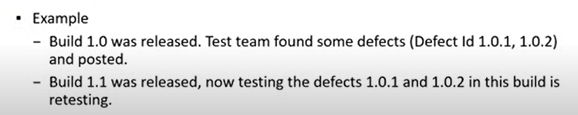

# Smoke Testing(Build Verification Testing)

## Whenever developer is providing build(software/application) to the tester team. Tester will do some **basic functionality test** in every build.

## First, we verify whether we got complete build or not, got installer properly or not, any files missing in the installer or not.

## Do installation part in QA environment, check build is stable or not to perform further test.

## Verifying the health check of the build.

## Basic navigation is working or not.

## Just focusing on the build.

## Conducted very frequently in every build by both developer and tester.

# Sanity Testing

## If smoke or sanity testing, got failed then we can reject the build and developer will create another build and provide that to the tester.

## To check the main/critical functionalities of the application without going deeper.

## It is performed by tester alone.

## It is planned when there is not enough time to do in-depth testing.

## Part(Subset) of Regression Testing

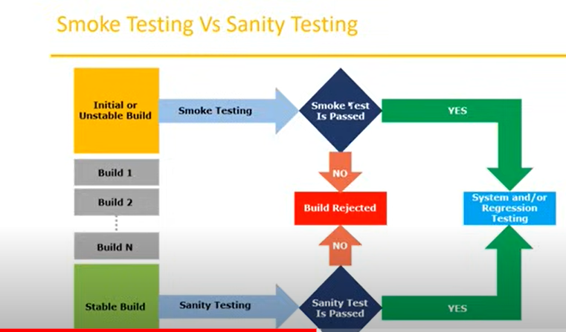

# Exploratory Testing

## No requirement , no documentation or delay in documentation(Test cases and Test Scenarios) is available, but your application is ready.

## You must test the application by exploring the functionality.

## Understand the application, identify all possible scenarios , document it then uses it for testing.

# Drawbacks

## Time consuming.

## If there is any bug in application, you will never know about it.

## You might misunderstand any feature as a bug or any bug as a feature since you do not have requirement.

# Adhoc Testing

## Testing application randomly without any test cases or any business requirement document.

## This is usually an unplanned activity.

## Main intension is to break(find defect at the corner level) the application.

## Testers use their intuition, experience, and creativity to identify defects and issues that more formal testing methods may not find.

# Monkey/Gorilla Testing

## Testing application randomly without any test cases or any business requirement document.

## Tester do not have knowledge of application.

## Suitable for gaming applications.

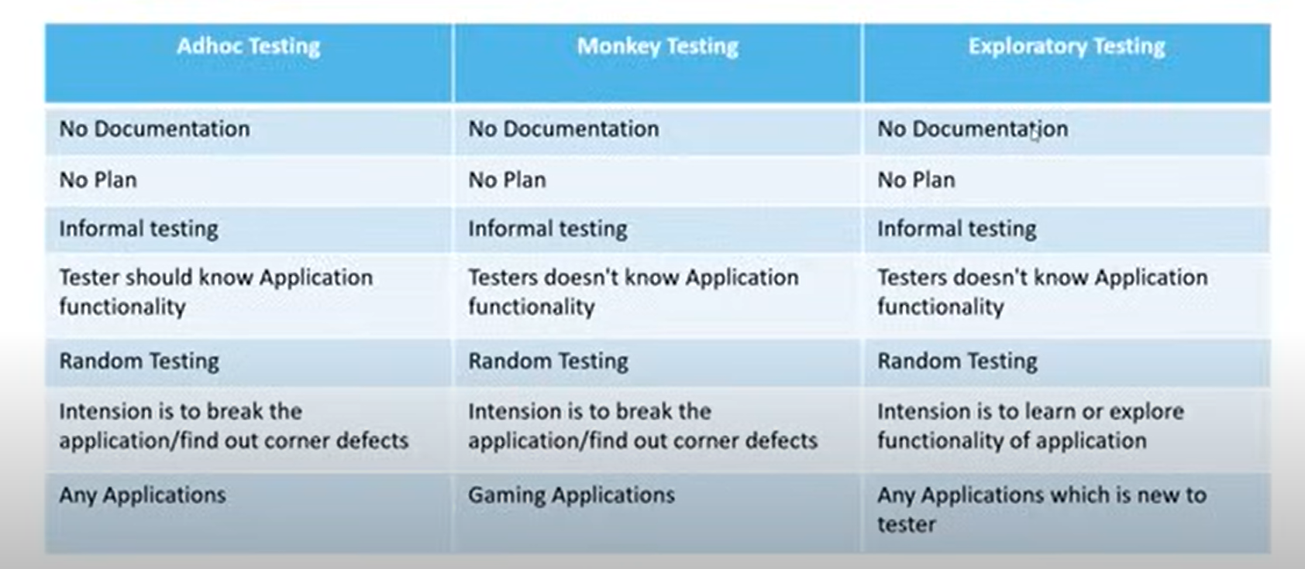

# Positive Testing

## Testing the application with valid/positive inputs is called positive testing.

## It checks whether an application behaves as expected with positive inputs.

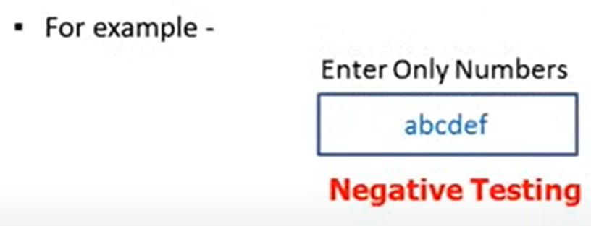

# Negative Testing

## Testing the application with invalid/negative inputs is called negative testing.

## It checks whether an application behaves as expected with negative inputs.

## Either System should not accept the values or else it should throw an error message for these invalid data inputs.

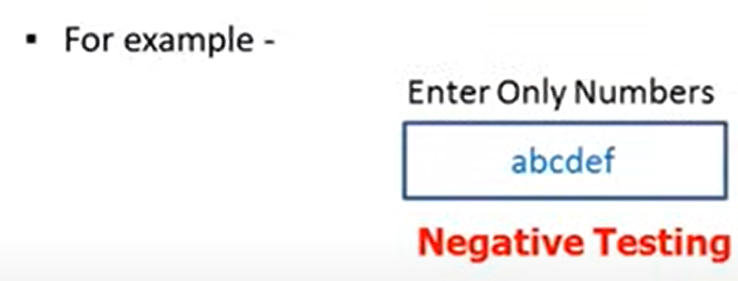

# Example:

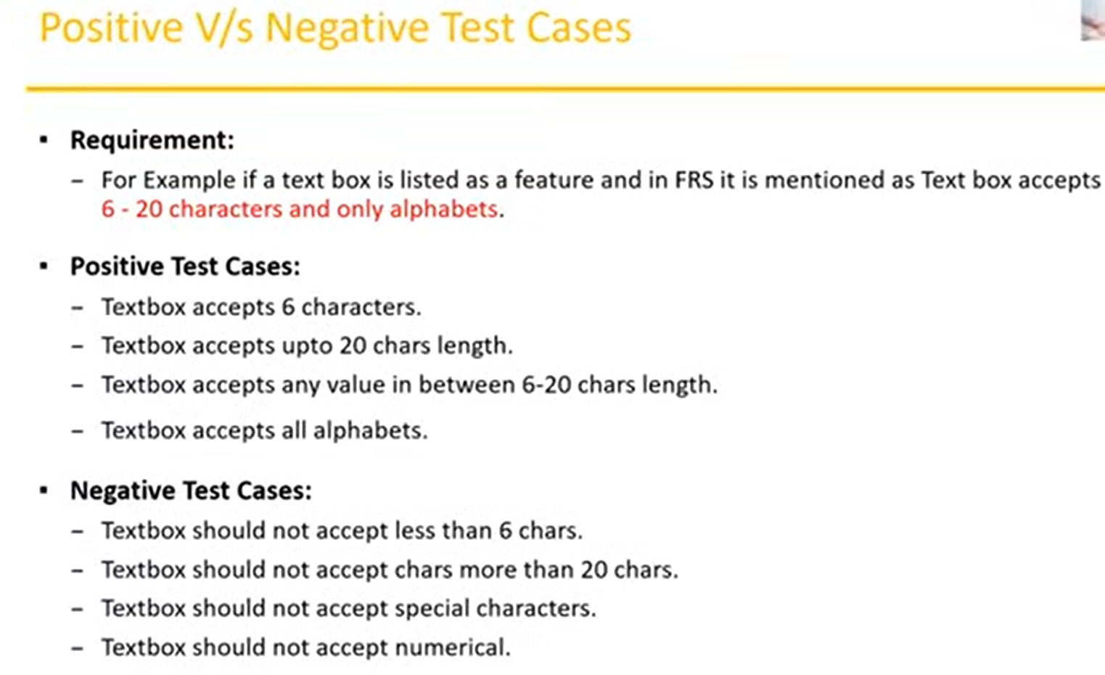

# End-To-End Testing

## Testing the overall functionalities of the system including the data integration(dependent flow) among all the modules.

## Sequentially it will cover all the components/modules.

## From login to logout whatever functionalities are there everything will be covered in sequential manner

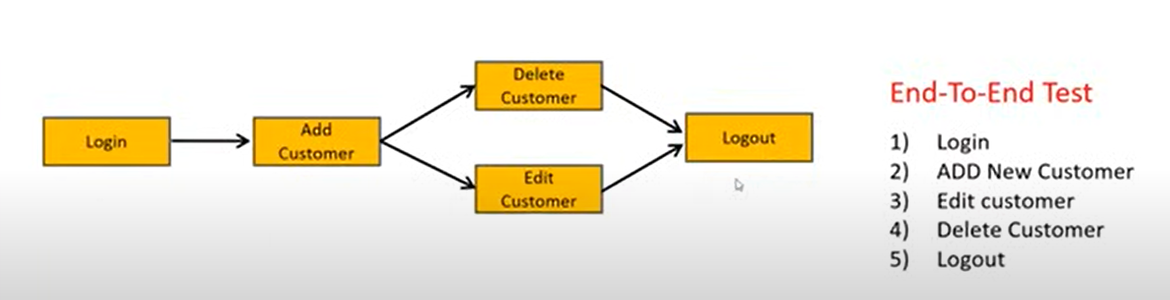

# I18N(Internationalization) Testing

# Globalization Testing

## Application is supporting globally or not, supporting all languages or not.

## Performed to ensure the system or software application can run in any cultural or local environment.

## It tests the different currency format; mobile number formats and address formats are supported by the application.

# Example: Facebook



# Localization Testing

## Performed to check the system or software application can run in specific geographical and cultural environment.

## Localized product only supports the specific kind of language and is usable only in specific region.

## It tests the specific currency format; mobile number formats and address formats is working properly or not.



# Test Design Techniques

## Used to prepare data for testing which will cover each area of the feature/functionality.

## We can also Reduce the Data and More Coverage.

## **Data**- We must prepare all combinations of data.

## **Coverage** – We must cover all the testing scenarios.

# Types

# Equivalence Class Partitioning (ECP)

## Focus on values.

## Divide/Partition data into various classes.

## Choose/Select one value/data from each class and then test it.

## It reduces the number of test-cases and saves time for testing.

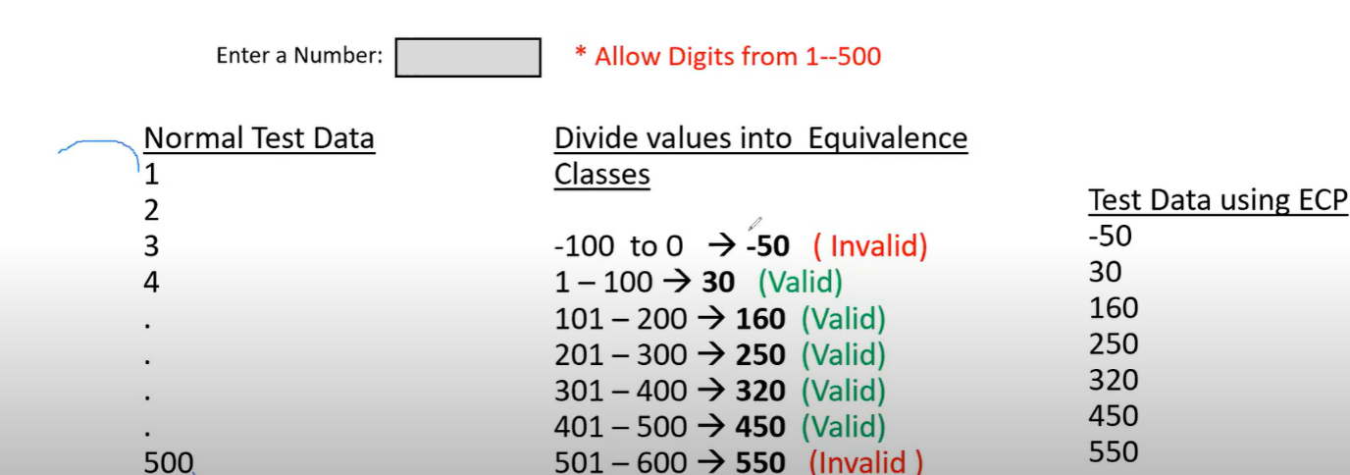

# Boundary Value Analysis

## Focus on Boundary of the value.

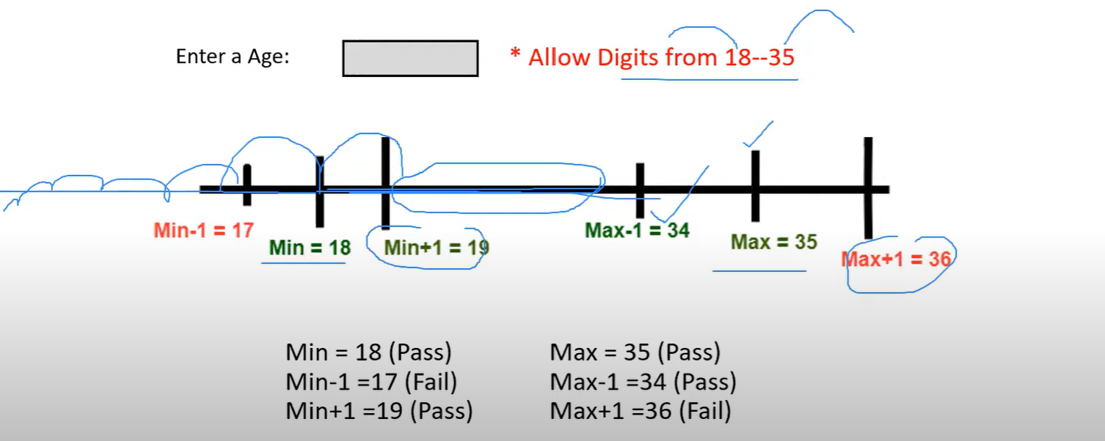

# Input domain testing

## The value will be verified in the textbox/input fields.

## Here we use ECP and BVA techniques.

# Decision Table

## Also called as Cause-Effect table.

## This technique will be used if we have more conditions and corresponding actions.

## It deals with combinations of input.

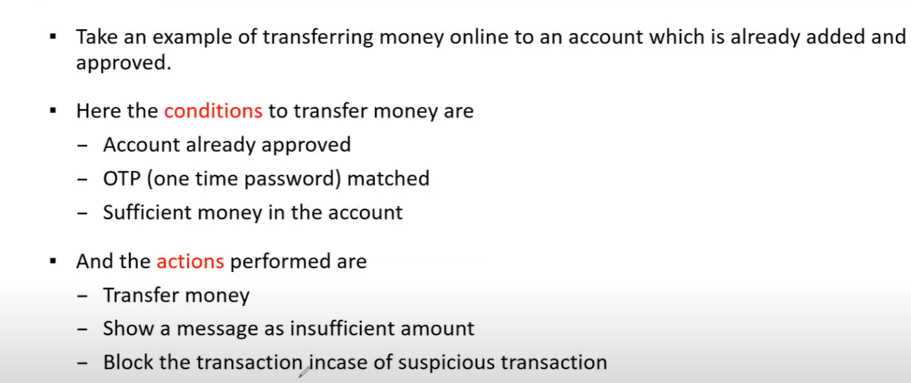

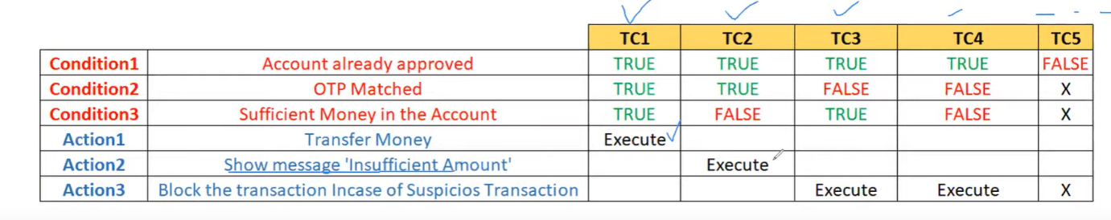

# State Transition

## Changing the condition from one state to another state based on the input condition.

## This allows to test the behavior of an AUT.

## Tester can perform this action by entering various input conditions in a sequence.

## Tester provides positive as well as negative input test values for evaluation system behavior.

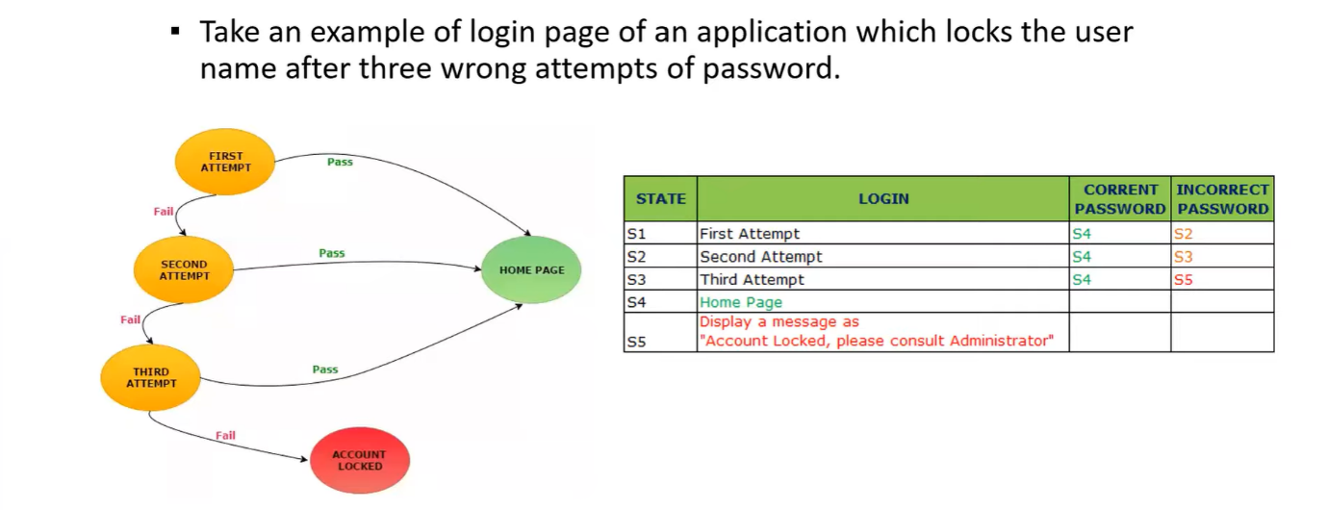

# Error Guessing

## Finding bugs in application based on testers prior experience.

## Depends on Tester Analytical skills and experience.

## We don’t need any specific rules.

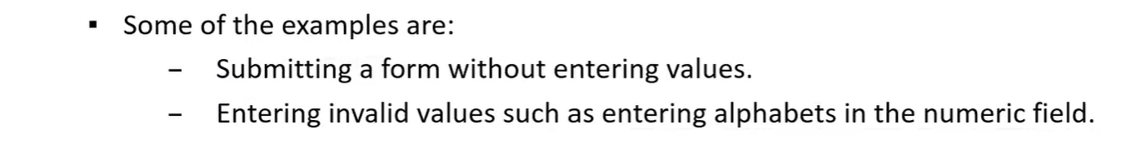

# STLC (Software Testing Life Cycle)

## It is a part/subset of SDLC.

## Come only during testing phase.

## It talks about testing process. Where exactly we must start, what are the documents we must prepare, what are the different people involve in software testing, what activities will be performed.

# Different phases in STLC

## Requirement Analysis

## Test Planning

## Test Design

## Test Execution

## Bug or Defect Reporting and Tracking

## Test Closure

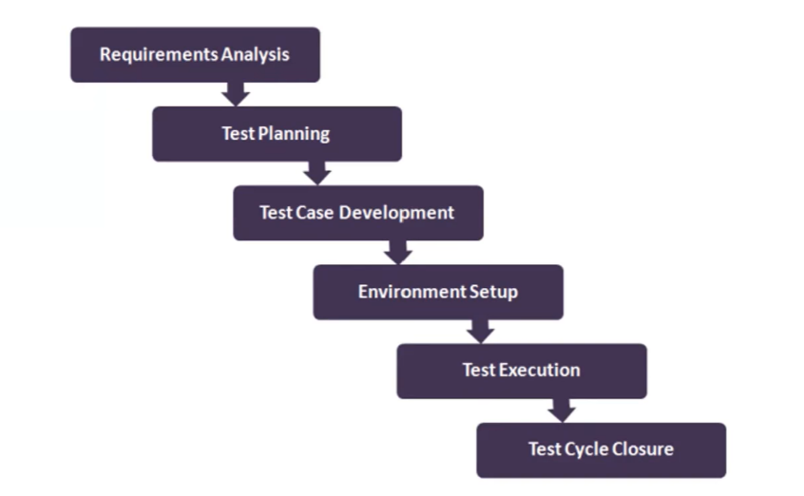

# Test Planning

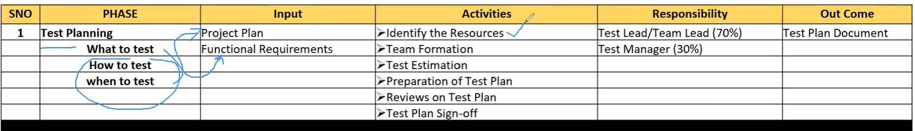

# Project plan

## Comes from management level.

## Very high-level documents which includes the timelines when exactly client approved the project.

## When we are going to start and when to deliver the project to customers.

## Budget, all the durations, hardware everything is the part of project plan.

# Test plan

## It is the document which contains all planning activities.

## Features to be tested.

## Features not to be tested.

## Different kinds of testing to be conducted.

## When to conduct the testing

## What are the team members are involved.

## Tools details to be used for testing.

## Once u have plan u need approval to implement the plan from the management team. They review and sign off(send mail to move forward).

# Test Designing

## Main activity is writing test cases.

# Input Document for Test Designing

## Project Plan

## Functional Requirement

## Test Plan

## Design documentation. – provides the information of application UI, size, width etc.

## Use Cases – describes the requirement by seeing the diagram.

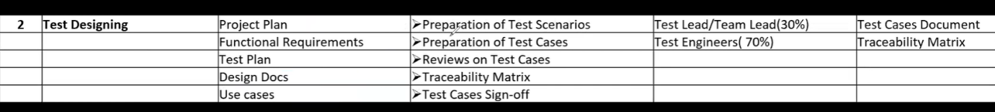

# Test Scenario

## Different areas to be tested like login, register.

## For one scenario we can create many numbers of test cases

# Test Cases

## Step by step action to be performed on the application to test the functionality of the feature.

# Traceability matrix(RTM)

## Mention all requirements and for each requirement wat are the test cases created.

## Mapping between requirements and Test Cases

## Requirement 1 how many Test cases are written.

## Traceability matrix says what requirements are covered and what are not covered.

# Test Plan

## It is a document which describes the test scope, test strategy, objectives, schedule, deliverables, and resources required to perform testing for software product.

## Before starting the testing, we will do planning.

# In test plan we must specify everything like

# Overview

## What is the project and why we are preparing test plan document.

## Small description

# Scope

## What to test(inclusions)

## What not to test(Exclusions)- Not part of requirement

## What is in our scope and not in our scope based on requirements.

# Test Strategy

## What kind of testing we going to perform?

## Smoke, Sanity, Automation, Manual

## Different test strategy we are going to use.

## What are the Testing types we going to use?

# Defect Reporting Procedure

## What is the exact process we going to follow to report the bugs.

# Roles/Responsibilities

## Who will review it.

## Who is the author of the document.

# Test Schedule

## When we are going to conduct the test

## Who will conduct the test?

## On which environment we conduct the test

# Test Deliverables

## What kind of document we are going to deliver

## Pricing of it

# Entry and Exit Criteria

## When we going to start and stop the testing

# Suspension and Resumption criteria

## Sometimes immediately we stop testing if something is not working, or broken in application, then after getting fix or new build we resume our testing.

## In which case we should stop testing and resume the testing

# Tools

## What kind of tools we are going to use in our testing both manual and automation

# Risks and Mitigations

## In middle of project some hardware is crashed then we must maintain backup machine.

# Approvals

## Who will approve test plan, test case we must mention clearly.

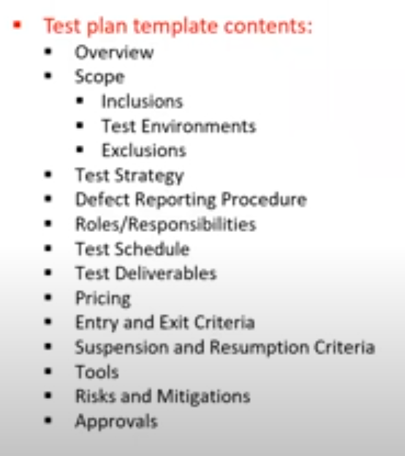

# Use Case

## Data flow diagram from which we can understand the requirement clearer.

## It describes the **requirement**.

## Product Manager or Product owner, Business Analyst will create use cases(responsible for writing FRS document).

# FRS(Functional Requirement Specification)

## In FRS, we describe the particular functionalities of every single page in detail from start to end.

## Focus on detailed aspects of the functional and non- functional requirements.

# Some Features

## This document elaborates on the functions to the user.

## Helps user to understand interactions of software and its behavior.

## It helps designing testing parameters for software.

## Provides better aid for wireframes and conceptual diagrams.

# Contains Three items:

## Actor – User(single person or group or person)

## Action – process to reach final outcome.

## Goal/Outcome – successful user outcome

# Test Scenario

## Based on the use case we derive the test scenario

## A possible area to be tested(What to test).

## It describes **What to test?**

## For Each scenario we will write multiple test cases.

# Example

## Login

## Registration

# Test Cases

## It describes what to the test?

## Step by step actions to be performed to validate functionality of AUT/software.

## It contains Test steps, expected result, actual result, test data.

## Prepared by tester.

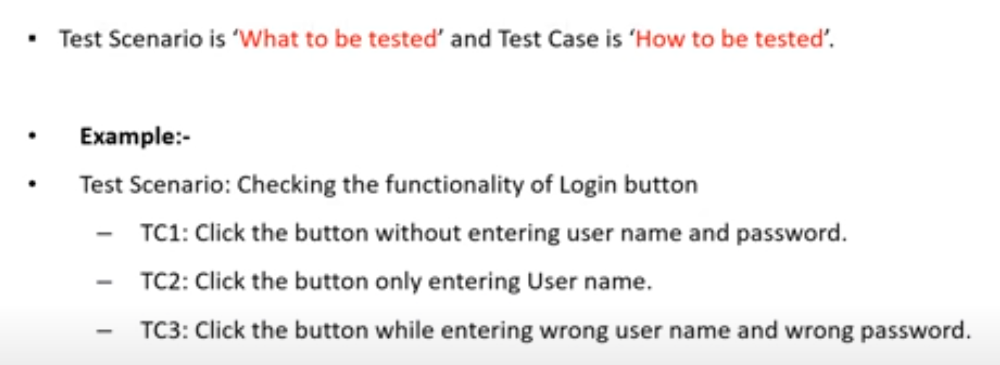

# Contents in Test Case

## It is a document/excel which contains below contents.

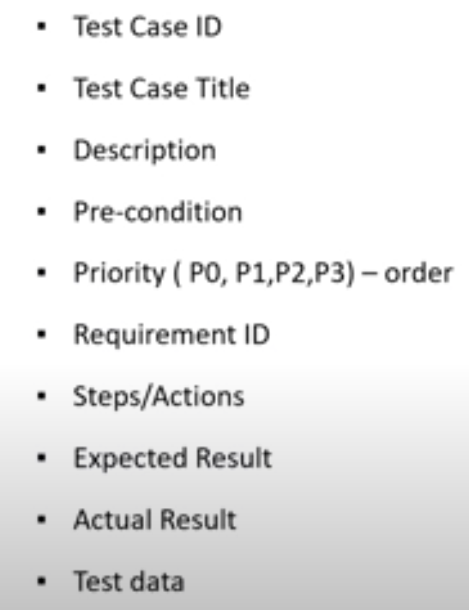

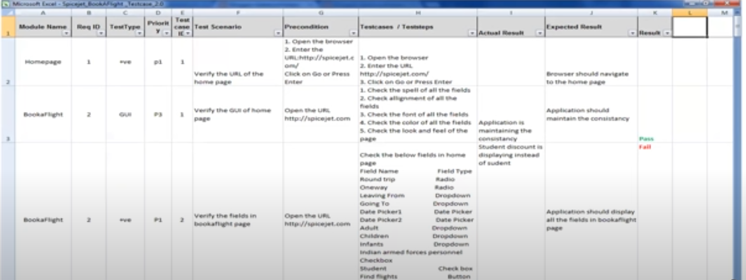

# Test suite

## Group of test cases which belong to same category.

# Example: Sanity Test cases, GUI test cases

# Requirement Traceability Matrix

## Mapping the requirements with the test cases

## Main purpose is to check all test cases are covered so that no functionality should miss while doing software testing.

## Tester will prepare this.

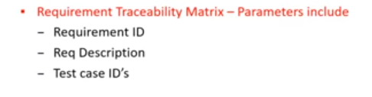

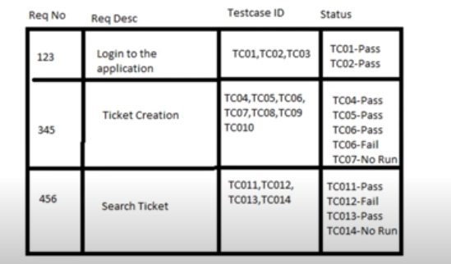

# Test Environment(Test Bed)

## Once design, test case everything is completed before receiving build from developer we have setup the environment.

## Certain hardware and software environment is required to perform testing.

## It is a platform specially build for test case execution on software product.

## It should be replica of customer environment.

## What kind of machine, processor, RAM, network speed

## What kind of software version they are using, kind of database, kind of OS.

## Test environment simulates production/real time environment.

## It is created by integrating the required software and hardware along with proper network configurations.

# Test Execution

## Once developer provided the build to testing team, we will install that software/application in QA environment then continue the testing.

# Prerequisites

## Approved Test Cases

## Test Data

## Test Plan

# Activities

## Test cases are executed based on test planning.

## Status of the test cases are marked like Passed, Failed, Blocked, Run

## Documentation of test results and log defects for failed case is done.

## All blocked and failed test cases are assigned bug ids.

## Retesting once defect is fixed.

## Defects are tracked till closure.

# Deliverables

## Provide defect and test case execution report with completed results.

# Defects/Bugs

## Any mismatched functionality found in an application is called Defect/Bug/Issue

## Functionality of application is not working according to requirement.

## During test execution Test Engineers are reporting mismatches as defects to developers through templates or using tools.

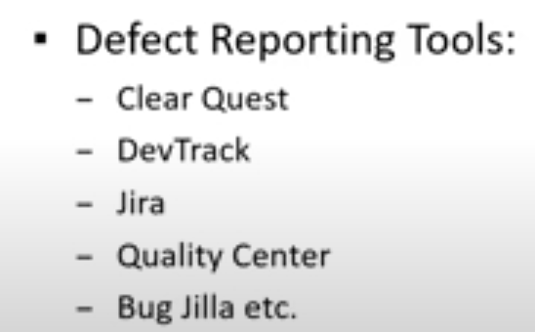

# Defect Report Contents

## Whenever we report defect to developer what are details, we must provide to the developer .

## Not only Defect ID even some detail information should be added.

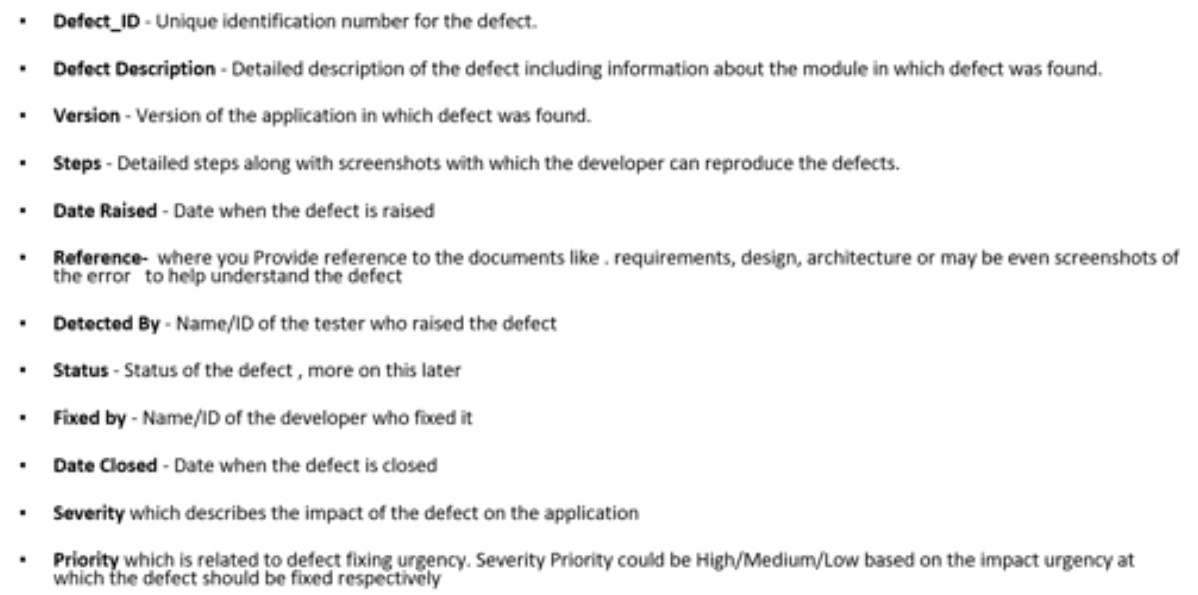

# Defect Classification

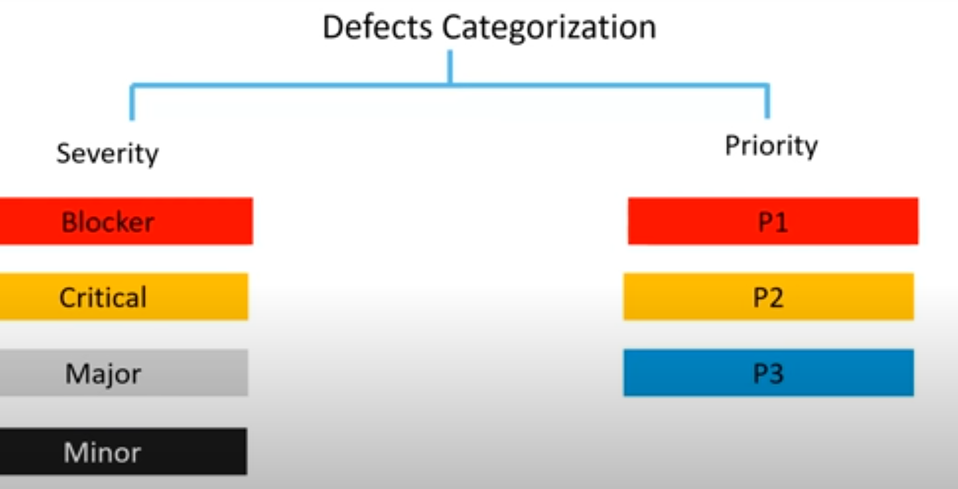

# Defect Severity

## It describes the **seriousness of defect** and how much impact on Business workflow.

# Blocker(Show Stopper)

## This defect indicates nothing can be proceeded further.

## Until unless developer fixed the bug you cannot proceed further. In that situation specify defect as blocker.

# Example

## Application Crash(Page not found)

## Login not working.

# Critical

## The main/basic functionality is not working.

## Customer business workflow is broken. They cannot proceed further.

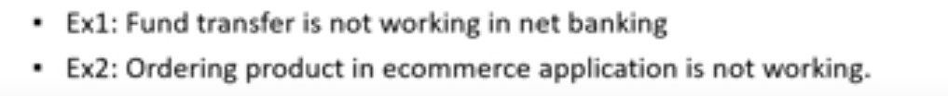

# Major

## Cause some undesirable behavior, but the feature/application is still functional.

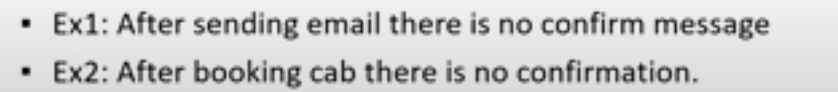

# Minor

## It won’t cause any major break-down of the system. It will not impact any functionality.



# Example: Cosmetic Issues

# Defect Priority

## It describes the importance of defect. How soon the developer should fix the defect.

## It states the order in which a defect should be fixed.

## Developer will choose the defect based on the priority we assigned.

## **P1**- within the release in new version it must be fixed.

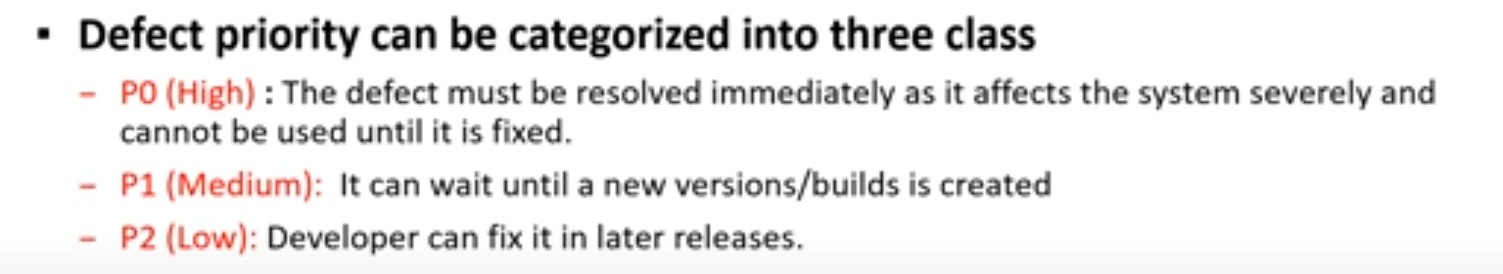

## Tester should provide the severity and priority.

## Priority can be changed by BA or Dev also, but Severity cannot be changed by anyone.

# High Severity, Priority and Low Severity, Priority Defects

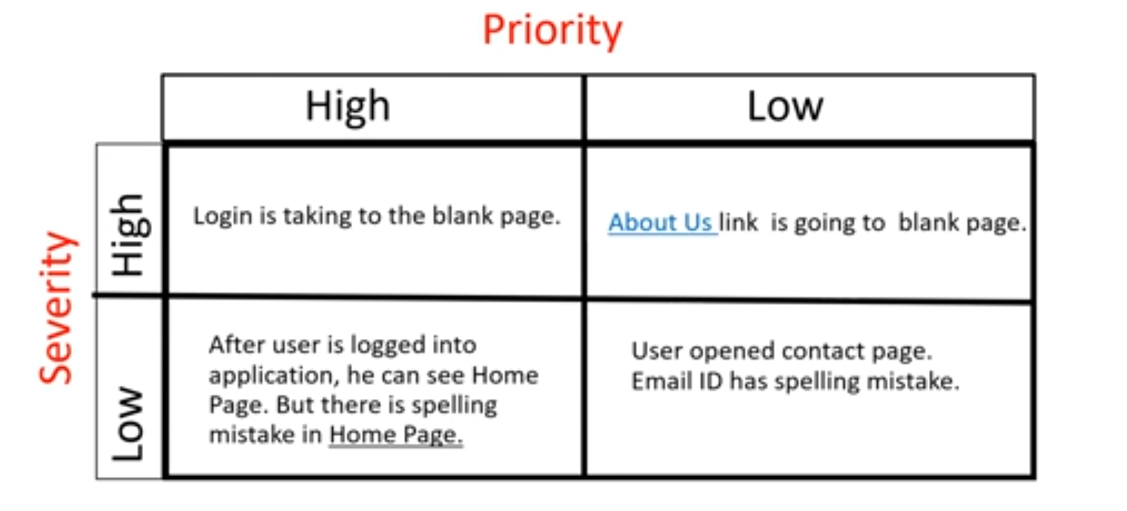

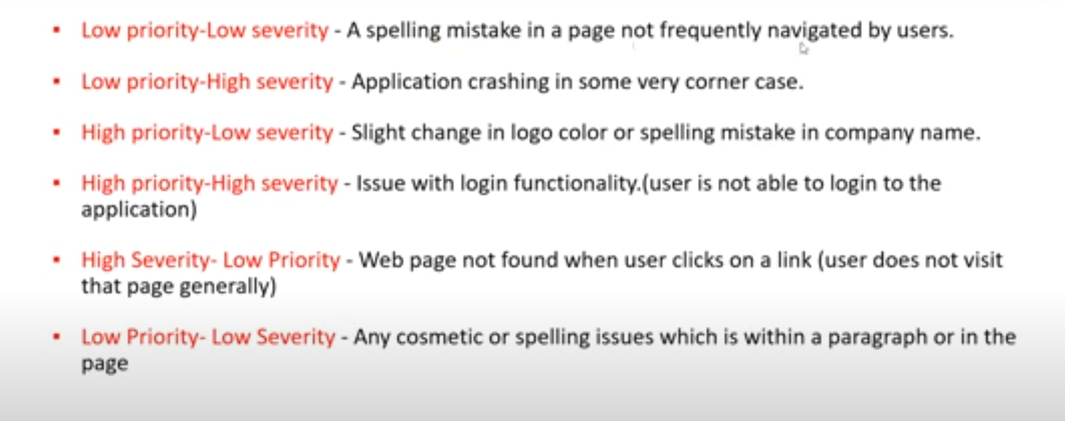

# Defect Resolution

## Opinion of the defect by developer.

## After receiving the defect from testing team, development team conduct a review meeting to fix defects.

## Then they send a Resolution Type to the testing team for further communication.

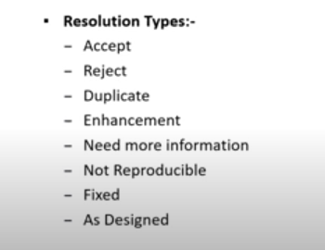

# Not Reproducible – Same bug is not producible in dev environment.

# As Designed - Actual functionality and it should suppose to work like that.

# Defect/Bug Life cycle

## State of the defect

## As soon as tester raise the bug the tool will automatically assig as New.

## **Enhancement** - In coming version they will implement that as a feature/functionality.

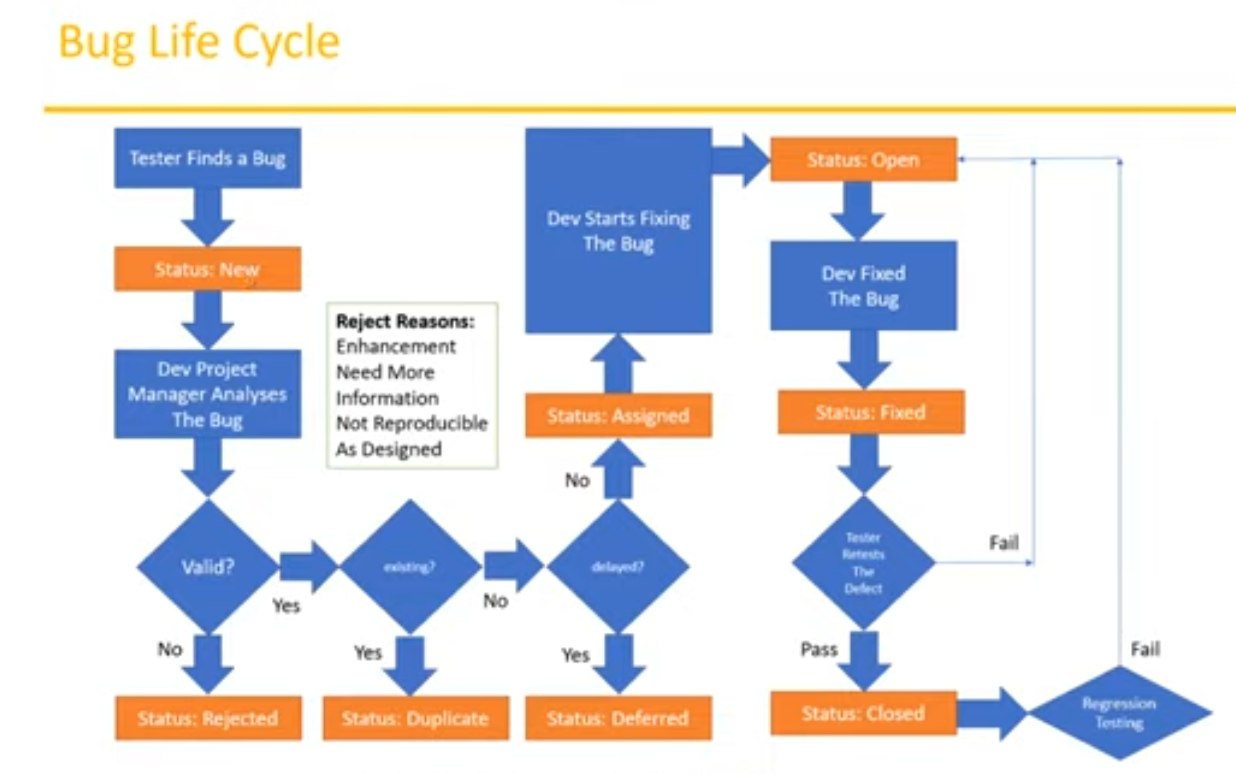

# Defect Status/State

# New :

## When tester finds issue

# Rejected:

## If defect is not valid

# Duplicate:

## If same kind of defect already exists

# Deferred:

## The bugs are in the queue.

## If the defect fixing is delayed

# Assigned :

## Then assigned to resource.

# Open:

## If dev starts fixing

# Fixed:

## If defect is fixed

# Closed:

## If tester retest and passed, then close

# Test Cycle Closure

## Stop our testing.

# When to stop?

## Once we met the criteria then we can stop the testing.

## Application should not have bugs(minor one or two is allowed).

## Make sure all test cases are executed, all bugs are closed, all test cases are passed or not, test cycles are completed or not.

# Deliverables

## Test Closure Report

## Test Metrics

# Test Metrics

## Whenever we do some tasks, we must measure that. Track it because we must know how much it is progressed, where are we now.

## Management will exactly know what was the exact status of the Project?

## We must collect the below data to calculate the metrics.

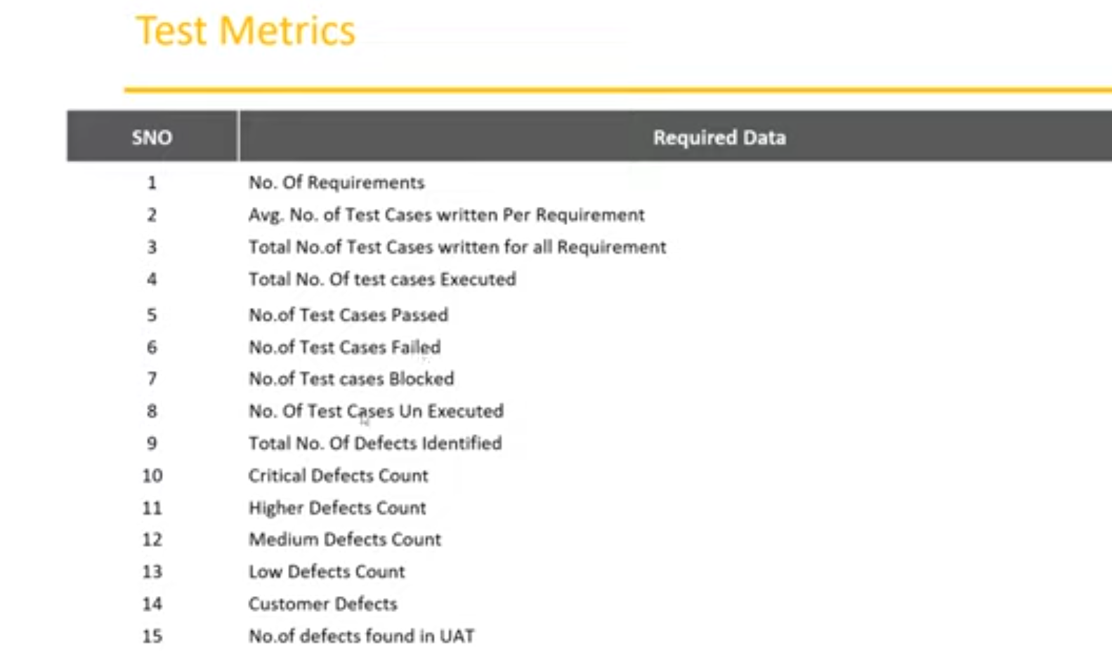

# Now calculate the metrics with the below formula.

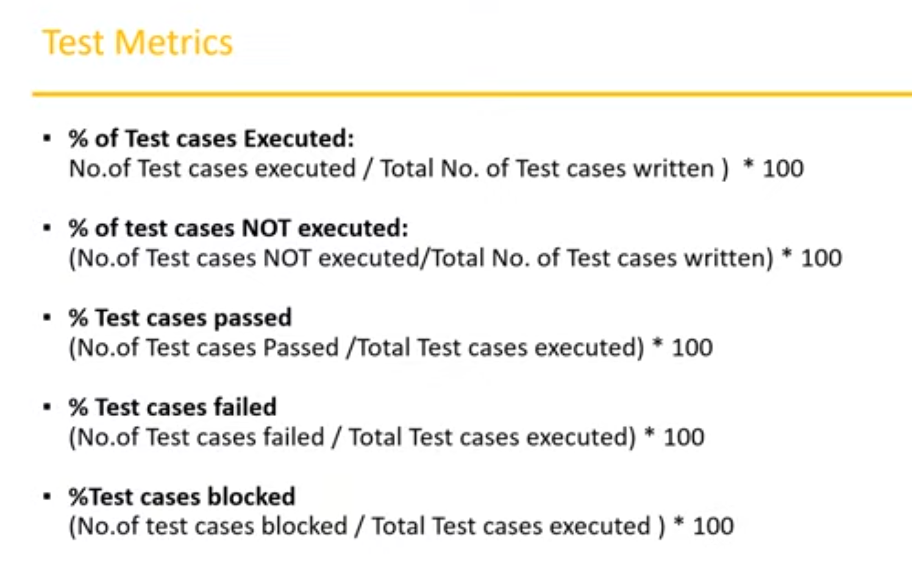

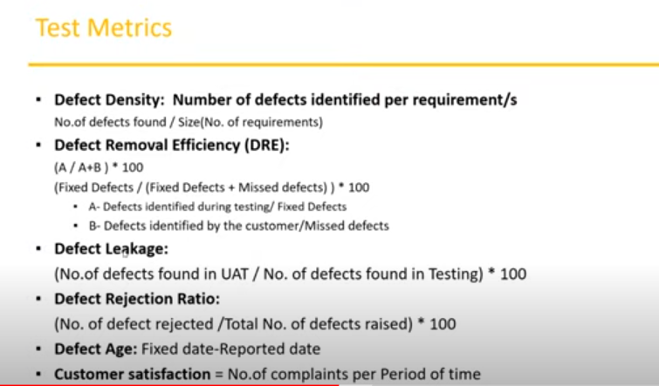

# Defect Density

## Defect density is the number of defects detected per lines of code or per module.

## It is a measure of the quality of the code — the better the [software quality](https://tuskr.app/learn/software-quality), the lower the density.

# Defect Leakage

## How many defects are missed/slipped during the QA testing.

# Defect Rejection Ratio

## DRR measures issues that were raised that ultimately had no impact on product quality(invalid defects).  This could easily be considered a measure of wasted effort and an opportunity for improvement.

# Daily Activities of Tester

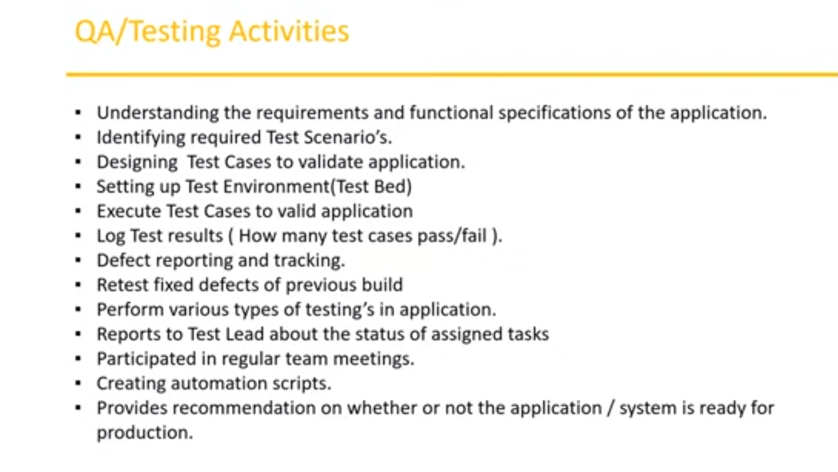

# Principles of Software Testing

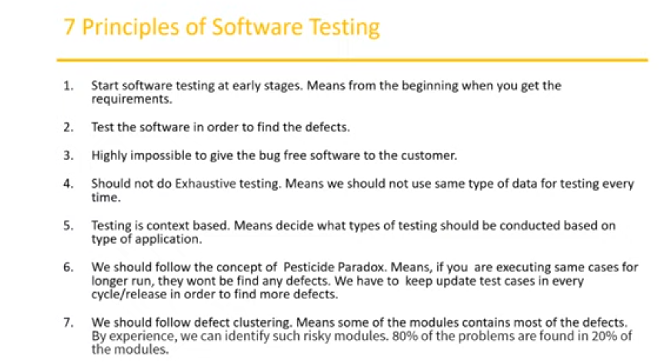

## 5. If web application we need to do performance testing. If desktop application, we don’t need performance testing.

# Based on Severity Types

## **Critical –** Blocks functionality and testing cannot proceed future .

## **Example**: Server error

## **High** – Key functionality of application is not working correctly .

## **Example**: search functionality is giving wrong results.

## **Medium –** Normal functionality not working .

## **Example**: Unable to update address.

## **Low –** Cosmetic issues

## UI is bad .

## **Example**: Color of button is green instead blue, spelling mistake)

# Priority

## **Urgent Defects –** Within 24 hours to be fixed (unable to login to application)

## **High Priority -** Need to be fixed before release (unable to change password or address)

## **Medium Priority –** Can be fixed in later release (unable to delete uploaded images)

## **Low Priority –** Fixed by final release (spelling mistake)

# How to prioritize test cases in short time

## Based on the previous release and execution first I will be analyzing the core functionalities of the application which is

## frequently used feature

## high risk areas.

## Based on the dependencies, if any test cases are rely on successful execution of others then I will prioritize that TCs

# Test Strategy(common understanding of testing)

## Organizational level document

## This will not change frequently.

## So whatever projects organization get they(all those projects) will follow the test strategy document.

## Tools used, kinds of testing, how defects will be tracked, reports.

# Test Plan (refers to test strategy)

## Contains more details on project along with test strategy.

## Project level document

## what kind of testing(regression, smoke, sanity) to perform,

## features to be tested and not to be tested.

## what are the tools we can use, which cycles or sprints we must test.

## Test Estimations (cycles and sprints)(time taken for testing)

## Resource and team details

## Can change frequently based on team.

## System requirements software and hardware.